Data Engineering

1. What is Data Engineering? What does a data engineer?
2. Data Warehouse
3. **OLAP (Online Analytical Processing) vs. OLTP (Online Transactional Processing)**

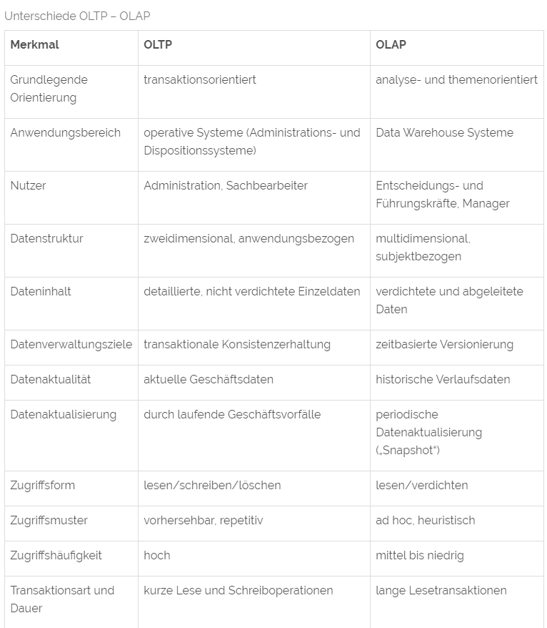

1. ETL vs. ELT
2. Big Data
   1. 4 Vs
   2. Hadoop
   3. Apache Spark
3. SQL
   1. Window Function
4. Programming Language